


March Newsletter



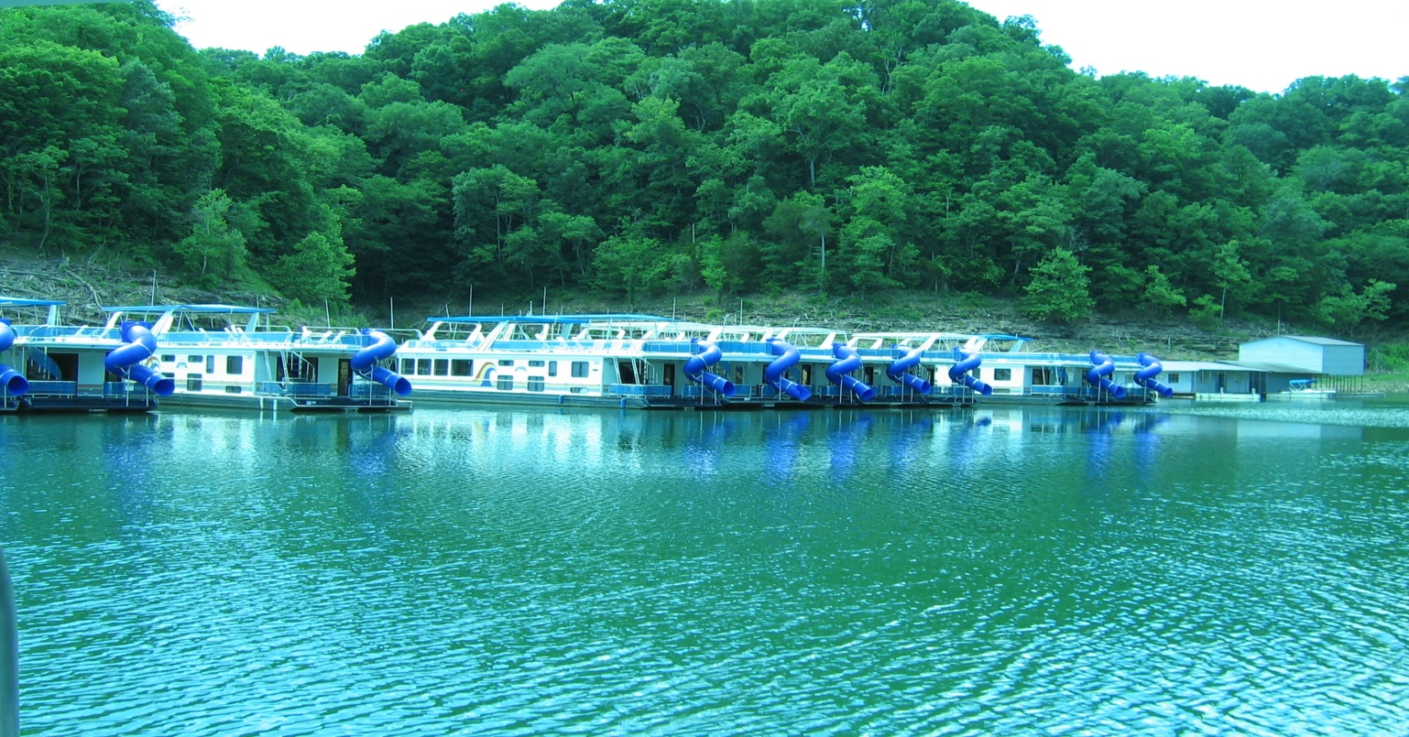
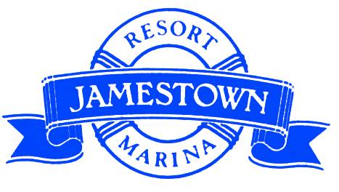The damages have been assessed after that huge storm rocked the dock in late January and the verdict is in: Boat Rentals is getting a BIG makeover!! The damages sustained to the dock were far too widespread to simply patch-up and move on – plans have been approved for the dock to be completely replaced from the Boat Rental Office building down to the Service Shop at the end of the dock. The dock will be 12ft wide (same as current), more dock ‘fingers’ will be added to reinforce the solidity of the structure, 2 new fuel fingers (with a new finger in between), and a slightly different layout will enhance the safety for our guests. Plus, it will be much more aesthetically pleasing to the eye!! The Browns Bridge Dock Manufacturing Company will be constructing, shipping, and placing the dock down at Boat rentals this spring. While under construction part of our rental fleet has been moved to the slips and we apologize for any inconvenience this may cause; but rest assured they will be moved as quickly as we get the new dock in place – which will be before the season gets under-way!! Thank you for your support and patience!!



This winter our staff has been hard at work on improvements for our ship store and café! The kitchen has been remodeled with a brand new floor, new walls, and new paint. And the ship store has been under the largest deep clean known to man!! The manager Patti Fulk has been painting shelves, shampooing carpets, replacing worn displays, dusting, cleaning, and getting ALL the summer dust O.U.T. We are pleased to announce that both the Ship Store and the Café will be opening the first weekend in April (with the café remaining open weekends only at first). Be sure to come in and grab a bite to eat!! We are offering all your old favorites and a few new items on the menu such as Breaded Frog Legs!!

Many of our most treasured guests and customers reside on various different time zones – so we would like to remind everyone that we DO recognize day light savings – Don’t forget to change your clocks!! Beyond March 10th the marina will be on day light savings in Central Standard Time After that we will be highly anticipating March 20th!! The first day of Spring marks the end of the winter and brings us closer yet to seeing all of our old friends back on the docks! More news coming soon on upcoming events/activities for the 2013 summer season - Please feel free to contact our Event Coordinator: Frieda Meincken, to plan your next party!
Continued Improvements
And BIG thanks to our Maintenance Manager, Joey Miller, and his winter crew!!

As we prepare for the upcoming 2013 boating season we would like to report how well property wide renovations are coming – thanks to an excellent winter maintenance staff we have been able to tackle more tasks than typical!! Our group facility, The Cumberland Room, is getting new carpet and upgraded; and our Yacht Club has undergone a full face-lift as well!! The Yacht Club has wall-to-wall new carpet, fully remodeled bathrooms, a new kitchenette, and a new storage closet!! Our maintenance crew has also remodeled a few cabins on top of the hill and repainted many of the lodge rooms. More renovations are on the docket for pre-season preparations and we will keep everyone posted as jobs are completed!! Thanks again to our skilled craftsman!!
REMINDER: Please make sure we have your current email address. This newsletter is going to remain an E-Blast on the web only!! So if you have not yet given us a valid email please do so as soon as possible – Thank You for your time!!




Don’t forget to check us out on Facebook!!

